LAB PROGRAM 3
Energy and Parking Management System – Abstract Class and Interface

3(a) Energy Management System
Code:
import java.util.Scanner;
abstract class EnergySource {
String sourceId;
String sourceName;
double energyGenerated;
EnergySource(String id, String name, double energy) {
sourceId = id;
sourceName = name;
energyGenerated = energy;
}
abstract double calculateEfficiency();
void displayDetails() {
System.out.println("Source ID: " + sourceId);
System.out.println("Source Name: " + sourceName);
System.out.println("Energy Generated: " + energyGenerated + " kWh");
System.out.printf("Efficiency: %.2f%%\n", calculateEfficiency());
System.out.println("------------------------------");
}
}
class SolarEnergy extends EnergySource {
SolarEnergy(String id, String name, double energy) {
super(id, name, energy);
}
double calculateEfficiency() {
return (energyGenerated / 5000.0) * 100.0;
}
}
class WindEnergy extends EnergySource {
WindEnergy(String id, String name, double energy) {
super(id, name, energy);
}
double calculateEfficiency() {
return (energyGenerated / 8000.0) * 100.0;
}
}
public class EnergyManagementSystem {
public static void main(String[] args) {
Scanner sc = new Scanner(System.in);
System.out.println("Name: Kritika Singh");
System.out.println("USN: 1BF25CS129");
System.out.print("Enter number of energy sources: ");
int n = sc.nextInt();
sc.nextLine();
EnergySource[] sources = new EnergySource[n];
for (int i = 0; i < n; i++) {
System.out.println("\n1. Solar Energy");
System.out.println("2. Wind Energy");
System.out.print("Choose energy source: ");
int choice = sc.nextInt();
sc.nextLine();
System.out.print("Enter Source ID: ");
String id = sc.nextLine();
System.out.print("Enter Source Name: ");
String name = sc.nextLine();
System.out.print("Enter Energy Generated (kWh): ");
double energy = sc.nextDouble();
sc.nextLine();
if (choice == 1) {
sources[i] = new SolarEnergy(id, name, energy);
} else if (choice == 2) {
sources[i] = new WindEnergy(id, name, energy);
} else {
System.out.println("Invalid choice. Try again.");
i--;
}
}
System.out.println("\n--- ENERGY SOURCE DETAILS ---");
for (int i = 0; i < n; i++) {
sources[i].displayDetails();
}
sc.close();
}
}

Output:
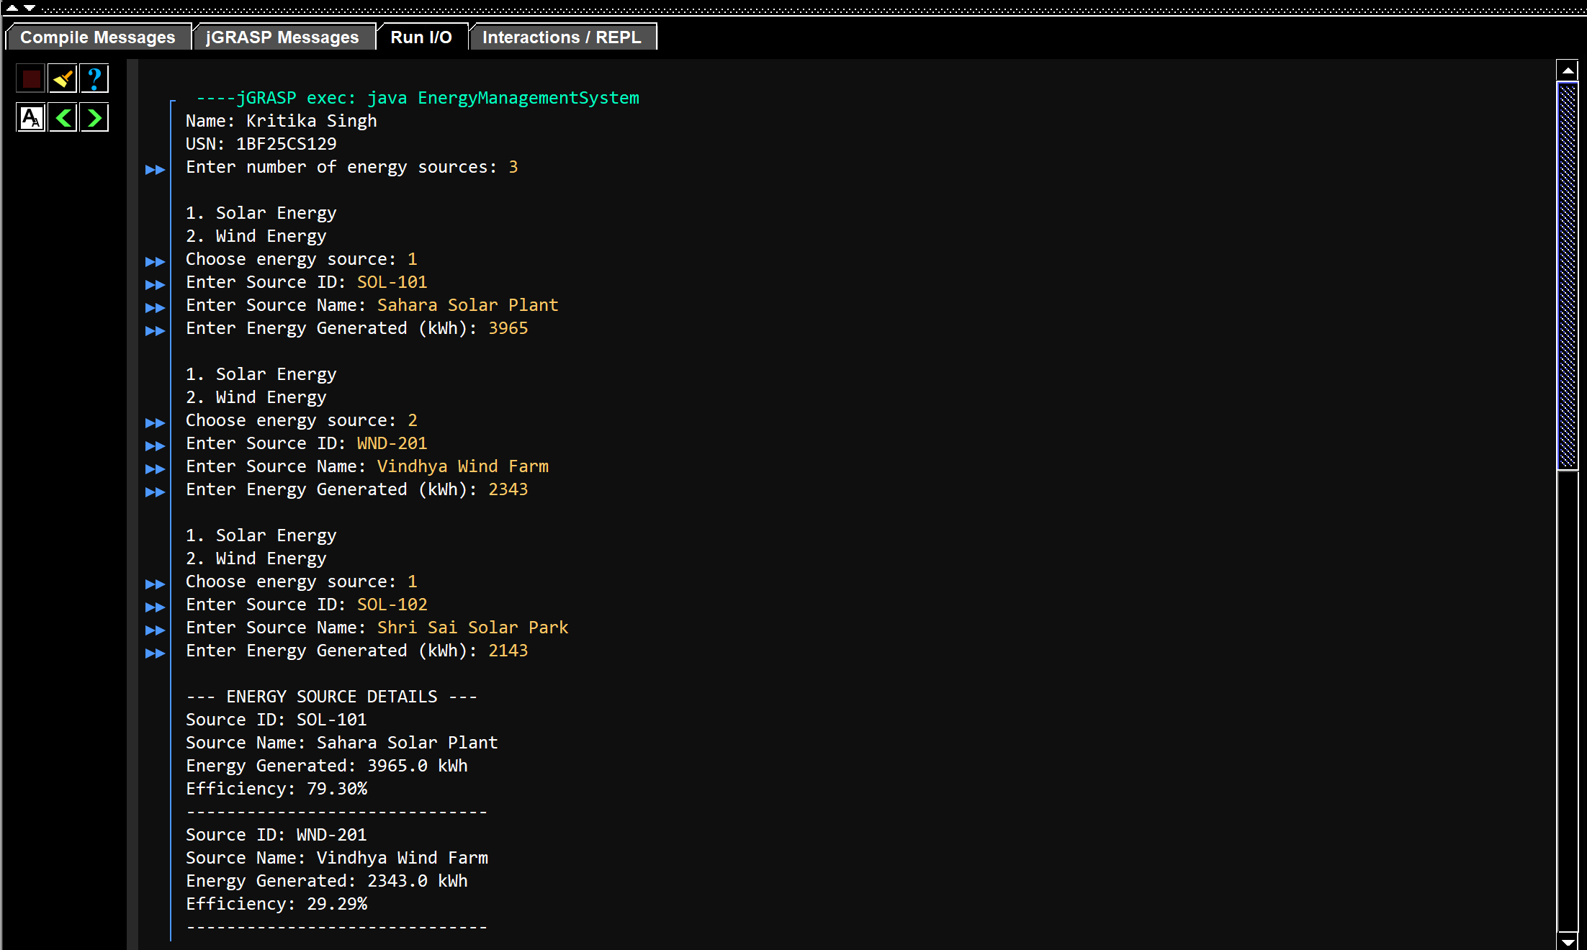
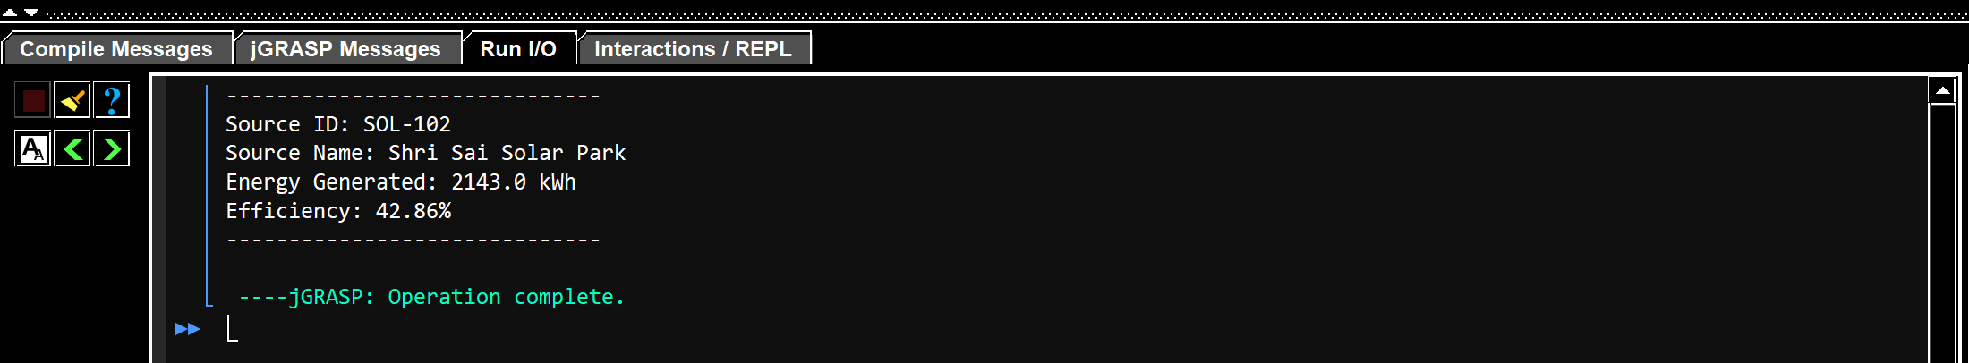

3(b) Parking Management System
Code:
import java.util.Scanner;
interface ParkingCharge {
double calculateCharge();
void displayParkingDetails();
}
class VehicleParking {
String vehicleNumber;
String vehicleType;
int parkingHours;
VehicleParking(String number, String type, int hours) {
vehicleNumber = number;
vehicleType = type;
parkingHours = hours;
}
}
class TwoWheeler extends VehicleParking implements ParkingCharge {
TwoWheeler(String number, int hours) {
super(number, "Two Wheeler", hours);
}
public double calculateCharge() {
if (parkingHours <= 2) {
return parkingHours * 20.0;
} else {
return 40.0 + (parkingHours - 2) * 10.0;
}
}
public void displayParkingDetails() {
System.out.println("Vehicle Number: " + vehicleNumber);
System.out.println("Vehicle Type: " + vehicleType);
System.out.println("Parking Hours: " + parkingHours);
System.out.println("Total Parking Charge: Rs. "
+ calculateCharge());
System.out.println("------------------------------");
}
}
class FourWheeler extends VehicleParking implements ParkingCharge {
FourWheeler(String number, int hours) {
super(number, "Four Wheeler", hours);
}
public double calculateCharge() {
if (parkingHours <= 2) {
return parkingHours * 50.0;
} else {
return 100.0 + (parkingHours - 2) * 30.0;
}
}
public void displayParkingDetails() {
System.out.println("Vehicle Number: " + vehicleNumber);
System.out.println("Vehicle Type: " + vehicleType);
System.out.println("Parking Hours: " + parkingHours);
System.out.println("Total Parking Charge: Rs. "
+ calculateCharge());
System.out.println("------------------------------");
}
}
public class ParkingManagementSystem {
public static void main(String[] args) {
Scanner sc = new Scanner(System.in);
System.out.println("Name: Kritika Singh");
System.out.println("USN: 1BF25CS129");
System.out.print("Enter number of vehicles: ");
int n = sc.nextInt();
sc.nextLine();
ParkingCharge[] vehicles = new ParkingCharge[n];
for (int i = 0; i < n; i++) {
System.out.println("\n1. Two Wheeler");
System.out.println("2. Four Wheeler");
System.out.print("Choose vehicle type: ");
int choice = sc.nextInt();
sc.nextLine();
if (choice != 1 && choice != 2) {
System.out.println("Invalid choice. Try again.");
i--;
continue;
}
System.out.print("Enter Vehicle Number: ");
String number = sc.nextLine();
System.out.print("Enter Parking Hours: ");
int hours = sc.nextInt();
sc.nextLine();
if (choice == 1) {
vehicles[i] = new TwoWheeler(number, hours);
} else {
vehicles[i] = new FourWheeler(number, hours);
}
}
System.out.println("\n--- PARKING DETAILS ---");
for (int i = 0; i < n; i++) {
vehicles[i].displayParkingDetails();
}
sc.close();
}
}

Output:


